HW1:
求下列JAVA程式的執行結果。
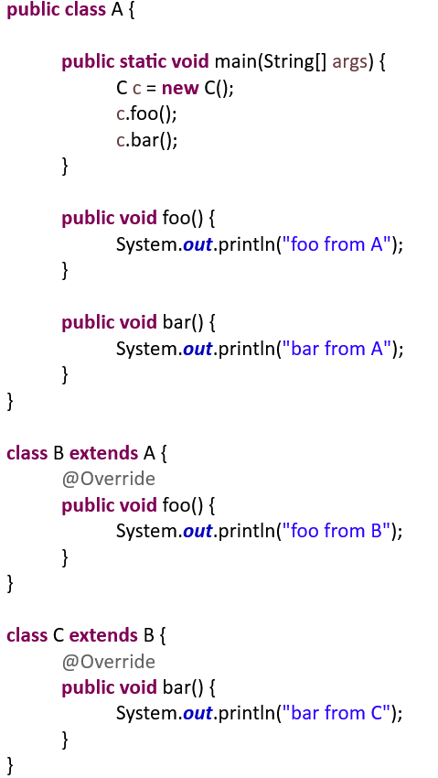
A :
foo from B
bar from C

HW2:
Fix the following program, make it OO.
import java.util.ArrayList;
public class EmployeeCensus extends ArrayList<Employee> {
public void addEmployee(Employee employee) {
add(employee);
}
public void removeEmployee(Employee employee) {
remove(employee);
}
}
class Employee {
// not important
}
A :
import java.util.ArrayList;
public class EmployeeCensus {
private ArrayList<Employee> employees
public EmployeeCensus (){
employees = new ArrayList<>();
}
public void addEmployee(Employee employee) {
employees.add(employee);
}
public void removeEmployee(Employee employee) {
employees.remove(employee);
}
}

class Employee {
// not important
}

HW3:
求下列JAVA程式的執行結果。
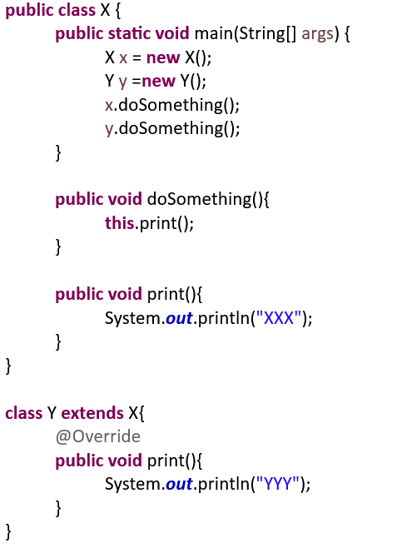
A :
XXX
YYY

HW4:
The following code is Java. There are some compilation errors in the code.
How can you fix it to pass compilation?
You can only change the code without deleting any lines of the code.

class SuperMan{
private int a;
protected SuperMan(int a){this.a = a;}
}
...
class SubMan extends SuperMan{
public SubMan(int a){super(a);}
public SubMan(){this.a = 5;}
}
A :
private int a; -> protected int a;
Or
public SubMan(){this.a = 5;} -> public SubMan(){super(5);}

HW5:
In C++, Kevin wrote the following code first
Class A {
A() ;
protected:
int foo ;
};
Class B : A {
B() ;
protected:
string bar ;
};
In main(), Kevin feel the need to initialize foo when needed
That is, he needs to declare a variable like
B b(100); // where 100 is to initialize foo.
Please modify the code the above to help Kevin.
A :
Class A {
Public:
A() {};
A(int a){
foo = a;
}
protected:
int foo ;
};
Class B : A {
Public:
B(){} ;
B(int a) : A(a){}
protected:
string bar ;
};
HW6:
What is the program output of the following C++ code:
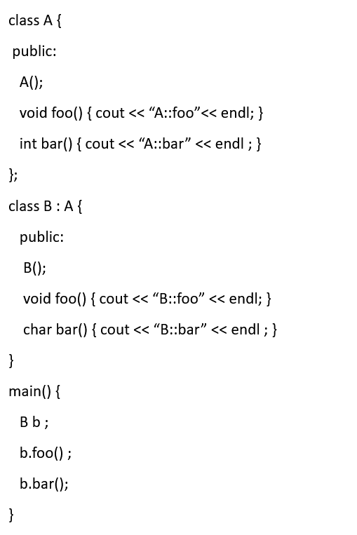
A :
B::foo
B::bar

